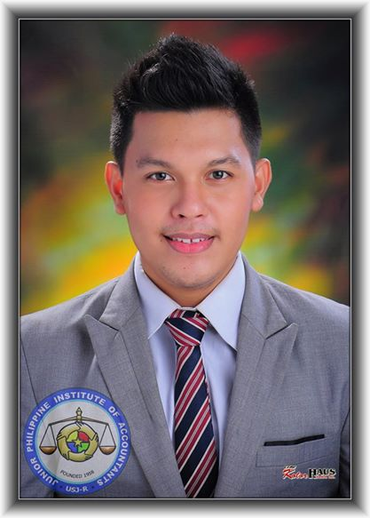

**BEDUYA, JOHN MARK B.**

Visitacion Street, Cebu City

09225115598

ohjmbstoic@gmail.com

**OBJECTIVE**

To obtain a position that will utilize my management, supervision and administrative skills to benefit mutual growth and success.

**WORK EXPERIENCE**

* Audit Intern, Philippine Spring Water Resources Inc.

A.C. Cortes Avenue, Cambaro, Mandaue City

November, 2015 – March, 2015

**EDUCATIONAL BACKGROUND**

* **Tertiary Education: University of San Jose-Recoletos**

Address: Magallanes Street, Cebu City

Program Taken: Bachelor of Science in Management Accounting

Estimated Year to Graduate: 2015

Award: Candidate for Magna Cum Laude

* **Secondary Education: Sto. Tomas College – Danao**

Address: Bonifacio Extension, Danao City, Cebu

Year Graduated: 2011

Award: Class Valedictorian

**ORGANIZATIONAL AFFILIATIONS**

* **Junior Philippine Institute of Accountants – USJ-R chapter**

Central Body Officer

2014-2015

* **USJ-R Supreme Student Council 33rd Congress**

Scholar, 2012-2015

* **USJ-R ANGLOPHILES**

President, June, 2011-March, 2012

* **Danao City Youth Officials**

President, June, 2012-March, 2012

* **Student Coordinating Body- Sto. Tomas College**

President, June, 2012-March, 2012

**AWARDS AND RECOGNITIONS**

* **Consistent Dean’s List**

Accountancy Department, College of Commerce, USJ-R

2011-2012, 2012-2013

* **Top 1, Accounting 2 Departmentals Exam**

Accountancy Department, College of Commerce, USJ-R

* **1st place JPIA Speech fest 2011, Extemporaneous Speaking Contest**

Junior Philippine Institute of Accountants,USJ-R

* **Outstanding Student Coordinating Body Officer**, STC-D, 2009-2011
* **Gerry Roxas Leadership Award**

**SEMINARS AND TRAININGS ATTENDED**

* **SAP Business One Training**

University of San Jose-Recoletos, June, 2014- October 2014

* **1st Recoletos International Congress**

University of San Jose-Recoletos, 2013

* **MEGA CEBU Symposium,** Cebu Coliseum2014

**SKILLS**

* Exceptional leadership skills developed through work experience in school as a consistent student leader
* Excellent communication skills in English both oral and written
* Proficient in computer applications such as MS Word, Excel, PowerPoint, Access and SAP
* Independent and can work with less supervision

**CHARACTER REFERENCES**

* **Mr. Edman P. Flores, CPA**

Chairman, Department of Accountancy and Finance, USJ-R

271-7900

* **Dr. Amelia Girly Aranas**

Faculty member, College of Arts and Sciences, USJ-R

09398481122

* **Mr. Leo Aberion**

Faculty member/ Adviser of Anglophiles USJ-R

271-7900